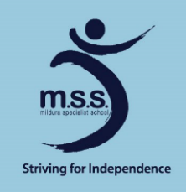
Mildura Specialist School

Coronavirus Update 10 April 2020

Following advice from the Victorian Government on Tuesday 7 April, Mildura Specialist School will be moving to remote and flexible learning from Term 2 (beginning with a pupil-free day).
This is a step all Victorian government schools are taking to help slow the spread of coronavirus (COVID-19). This means that all students who can learn at home must learn from home. This is a very clear directive from the Victorian Government based on the advice of the Chief Health Officer.
We will continue to offer limited on-site learning for those students who need to access this, including for students on days when they are not able to be supervised at home and no other arrangements can be made. Please contact me directly if you would like to discuss a plan for your child by calling the school on 5021 3311 or emailing mildura.ss@edumail.vic.gov.au. There is an On-Site Attendance Application Form for completion where you can indicate the days/times you require your child/ren to attend school on site if eligibility is met.

Please continue to access our website https://www.mildss.vic.edu.au for the latest information.
The Department’s latest advice on coronavirus can be found at https://www.education.vic.gov.au/coronavirus
It is important that we work together and support each other during this challenging time. We will be in touch with staff and parents and carers shortly with further details of what remote and flexible learning will look like at our school. Consistent with the Victorian Government’s advice, staff who can work from home from Tuesday 14 April must work from home. This applies to all staff.
In the meantime, you might find it useful to look at the Department’s Learning from Home website. It provides resources and guidance for teachers and parents and carers. https://www.education.vic.gov.au/about/department/Pages/learningfromhome.aspx

