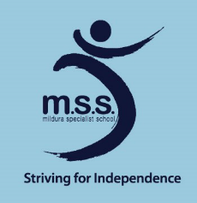
Mildura Specialist School
Remote Learning
Term 2, 2020

Our mission, Striving for Independence inspires us to create challenges for our students to be the best they can be.

Vision
We aim for individual responsibility, social and academic growth.

School Values
The school values, Be Responsible, Be Respectful and Be Safe are important aspects in daily life and are explicitly taught throughout the school at all levels.

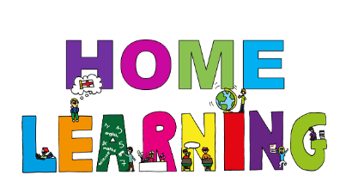
Learning
At Mildura Specialist School we are dedicated to ensuring that we are looking after our school community and that everyone is safe, feels supported and is continuing to learn and grow during this unprecedented time in history.

During remote learning classroom and specialist teachers will be providing learning packs for students. Teachers will design these packs to incorporate goals set in Individual Learning Plans and the wider curriculum. Arrangements for the pick-up and delivery of packs will be made with your child's class teacher.

The packs will include a suggested timetable, literacy and numeracy activities, online website addresses if you wish to access these, physical activity suggestions as well as art, science and mindfulness/drama ideas. We recommend frequent movement breaks between activities.

If you don’t have any access to an iPad or Laptop, or need access to the internet, we can lend this to you. Please ask us if you need these items.

Remote learning is applicable for all students. It is not independent learning. All school staff will directly support and engage in individual student's remote learning. Parents will be required to support their child’s learning during the day.

Please keep all completed and incomplete worksheets together. As these will need to be returned to school for assessments and feedback.

Students eligible for on-site learning will access the same program as students learning remotely. They will be supervised by staff on a voluntary basis with social distancing and recommended hygiene practices in place.

Teachers with parents and carers
Classroom teachers will communicate with parents and carers by phone and email. Each class has their own email address. Please see the school website for details: https://www.mildss.vic.edu.au
Specialist teachers will also be involved in contacting families and will do so in consultation with classroom teachers. Specialist teachers have email addresses on our website also. We want to ensure we keep in contact at times which suit you. Teachers will communicate with the parents and carers of on and off site students. If your contact details (phone, email) change at any time please let your child's teacher know.

Allied Health
Our Speech Therapists, Zorica and Steph will make calls to parents and carers as required. Megan (OT) and Rowena (Physio) will also be available on Mondays and Tuesdays to consult with teachers and families. Zorica and Steph have email addresses on our website.

Parents and carers with teachers
If you wish to communicate with your child’s teacher about their learning, email the class address. Teachers will only reply and be contactable during school hours.
Monday – Wednesday 8.45-4.45pm
Thursday and Friday 8.45-3.45pm

All staff will be working from home unless they are at school supervising students or preparing resources. Teachers and Education Support Staff will still be in meetings during the day so teachers may not always reply straight away. They will do their best to communicate as soon as possible. There may be times when staff are unwell. A member of the leadership team will contact families in these instances.

Parents and carers with the school
If you need to communicate with the school around other issues, (e.g. welfare, travel arrangements, other concerns), you can contact the school on 5021 3311 or by using the school email, mildss@edumail.vic.gov.au.

School with community
We will still be issuing a Newsletter every second Thursday. This will be emailed or provided in packs. As usual you will be able to access this on the website. Please check the Announcements section for updated information about the Coronavirus situation.

Student Wellbeing
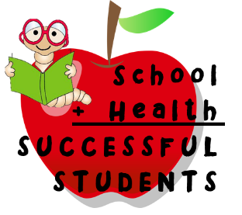
During remote learning we still place a high priority on ensuring the health and wellbeing of our students. Many students connect with Darren Jones, our Student Engagement Coordinator during the day at school. Darren has an email address on the website. Please email to contact Darren. You can also make contact in discussions with your child's teacher.

Please remember to take care of yourselves as well and have some fun with your child/ren as you work together. Learning can take place in so many ways. There are lots of skills involved in putting sheets on a bed, stacking the dishwasher or sweeping the floor, for example. We understand there may be times when something else happens at home, that's okay.

We are here to help. Our wish first and foremost is for everyone to stay safe and well during this time. Thank you and keep in touch.

